Selenium WebDriver Assessment

SECTION A: Conceptual Questions
Q1. Why is Java suitable for building reusable automation logic?
Java is suitable for Selenium automation because:
- Object-Oriented: Supports classes, inheritance, encapsulation — enables reusable Page Object Models
- Platform Independent: Write once, run anywhere via JVM
- Strong Typing: Catches errors at compile time
- Rich Libraries: TestNG, JUnit, Maven, Log4j all integrate seamlessly
- Community Support: Largest Selenium community uses Java

Q2. How control statements handle intermittent login failures?
if (loginSuccess) {
// proceed to next step
} else if (errorMessage.contains("Invalid Password")) {
// retry logic
} else {
// log failure and skip
}
- if-else handles pass/fail outcomes
- try-catch handles unexpected crashes
- for loops handle retries

Q3. How string handling validates dynamic error messages?
- equals() → exact match
- contains() → partial match for dynamic text
- trim() → removes spaces
- equalsIgnoreCase() → case-insensitive comparison
String actual = driver.findElement(By.id("error")).getText();

if (actual.contains("Invalid credentials")) {
System.out.println("Correct error message");
}

Q4. How OOP improves maintainability in automation frameworks?
OOP Concept | Benefit in Automation
Encapsulation | Hides internal logic, exposes only needed methods
Inheritance | Base test class reused by all test classes
Polymorphism | Same method name, different login types
Abstraction | Page Object Model hides element details

Q5. How exception handling prevents script termination?
try {
performLogin(username, password);
} catch (InvalidLoginException e) {
System.out.println("Handled: " + e.getMessage());
} finally {
driver.quit(); // always runs
}
- Script continues even after failure
- finally ensures cleanup always happens

SECTION B: Practical Tasks
Task 1: Conditional Login Validation
package com.demo;

import java.util.Scanner;

public class ConditionalLogin {

// Hardcoded valid credentials
static final String VALID_USERNAME = "admin";
static final String VALID_PASSWORD = "admin123";

public static void main(String[] args) {

Scanner scanner = new Scanner(System.in);

System.out.println("========== LOGIN SYSTEM ==========");
System.out.print("Enter Username: ");
String username = scanner.nextLine();

System.out.print("Enter Password: ");
String password = scanner.nextLine();

// Validate credentials using if-else
if (username == null || username.isEmpty()) {
System.out.println("ERROR: Username cannot be empty!");

} else if (password == null || password.isEmpty()) {
System.out.println("ERROR: Password cannot be empty!");

} else if (username.equals(VALID_USERNAME) &&
password.equals(VALID_PASSWORD)) {
System.out.println("Login Successful! Welcome, " + username);

} else if (!username.equals(VALID_USERNAME)) {
System.out.println("Access Denied! Invalid Username.");

} else {
System.out.println("Access Denied! Invalid Password.");
}

scanner.close();
}
}
Output:
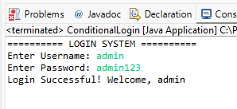
Task 2: Multi-User Testing (Arrays/Collections)
package com.demo;

import java.util.HashMap;
import java.util.Map;

public class MultiUserLogin {

// Valid credentials store
static final String VALID_USERNAME = "admin";
static final String VALID_PASSWORD = "admin123";

// Login validation method
static String validateLogin(String username, String password) {
if (username.equals(VALID_USERNAME) &&
password.equals(VALID_PASSWORD)) {
return "PASS - Login Successful";
} else {
return "FAIL - Access Denied";
}
}

public static void main(String[] args) {

System.out.println("====== BATCH LOGIN TEST ======\n");

// ---- METHOD 1: Using HashMap ----
System.out.println("--- HashMap Approach ---");

HashMap<String, String> credentialsMap = new HashMap<>();
credentialsMap.put("admin", "admin123"); // Valid
credentialsMap.put("user1", "pass456"); // Invalid
credentialsMap.put("tester", "test789"); // Invalid
credentialsMap.put("admin", "wrongpass"); // Wrong password
credentialsMap.put("guest", "guest001"); // Invalid

int mapPass = 0, mapFail = 0;

for (Map.Entry<String, String> entry : credentialsMap.entrySet()) {
String user = entry.getKey();
String pass = entry.getValue();
String result = validateLogin(user, pass);

System.out.println("User: " + user +
" | Pass: " + pass +
" | Result: " + result);

if (result.startsWith("PASS")) mapPass++;
else mapFail++;
}

System.out.println("\nHashMap Summary → Pass: " + mapPass +
" | Fail: " + mapFail);

// ---- METHOD 2: Using 2D Array ----
System.out.println("\n--- 2D Array Approach ---");

String[][] credentials2D = {
{"admin", "admin123"}, // Valid
{"user2", "pass000"}, // Invalid
{"manager", "mgr456"}, // Invalid
{"admin", "admin123"}, // Valid
{"hacker", "hack999"} // Invalid
};

int arrPass = 0, arrFail = 0;

for (String[] cred : credentials2D) {
String user = cred[0];
String pass = cred[1];
String result = validateLogin(user, pass);

System.out.println("User: " + user +
" | Pass: " + pass +
" | Result: " + result);

if (result.startsWith("PASS")) arrPass++;
else arrFail++;
}

System.out.println("\n2D Array Summary → Pass: " + arrPass +
" | Fail: " + arrFail);
System.out.println("\n====== BATCH TEST COMPLETE ======");
}
}
Output:
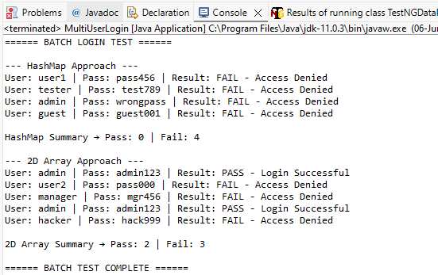

Task 3: Method Overloading
package com.demo;

public class LoginOverloading {

// Valid credentials
static final String VALID_USER = "admin";
static final String VALID_PASS = "admin123";
static final int VALID_OTP = 123456;
static final long VALID_PHONE = 9876543210L;

// ---- Overload 1: Username + Password ----
static void login(String username, String password) {
System.out.println("\n[Method 1] Username + Password Login");
System.out.println("Attempting: " + username + " / " + password);

if (username.equals(VALID_USER) && password.equals(VALID_PASS)) {
System.out.println(" Login Successful!");
} else {
System.out.println(" Access Denied!");
}
}

// ---- Overload 2: Username + Password + OTP ----
static void login(String username, String password, int otp) {
System.out.println("\n[Method 2] Username + Password + OTP Login");
System.out.println("Attempting: " + username +
" / " + password +
" / OTP: " + otp);

if (username.equals(VALID_USER) &&
password.equals(VALID_PASS) &&
otp == VALID_OTP) {
System.out.println(" Two-Factor Login Successful!");
} else {
System.out.println(" Access Denied! Check OTP.");
}
}

// ---- Overload 3: Phone Number + Password ----
static void login(long phoneNumber, String password) {
System.out.println("\n[Method 3] Phone Number + Password Login");
System.out.println("Attempting: " + phoneNumber + " / " + password);

if (phoneNumber == VALID_PHONE && password.equals(VALID_PASS)) {
System.out.println(" Phone Login Successful!");
} else {
System.out.println(" Access Denied! Invalid Phone/Password.");
}
}

public static void main(String[] args) {

System.out.println("====== METHOD OVERLOADING DEMO ======");

// Test Overload 1
login("admin", "admin123"); // PASS
login("admin", "wrongpass"); // FAIL

// Test Overload 2
login("admin", "admin123", 123456); // PASS
login("admin", "admin123", 999999); // FAIL - wrong OTP

// Test Overload 3
login(9876543210L, "admin123"); // PASS
login(1234567890L, "admin123"); // FAIL - wrong phone

System.out.println("\n====== DEMO COMPLETE ======");
}
}
Output:
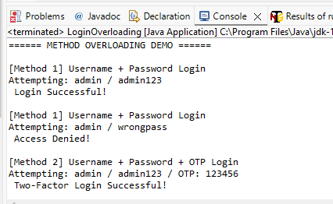
Task 4: Exception Handling with Custom Exception
package com.demo;

// Custom Exception
class LoginException extends Exception {
public LoginException(String message) {
super(message);
}
}

public class ExceptionHandlingLogin {

static String validUser = "admin";
static String validPass = "admin123";

public static void checkLogin(String username, String password)
throws LoginException {

if (username.isEmpty()) {
throw new LoginException("Username is empty");
}

if (password.isEmpty()) {
throw new LoginException("Password is empty");
}

if (!username.equals(validUser) || !password.equals(validPass)) {
throw new LoginException("Invalid Username or Password");
}

System.out.println("Login Successful");
}

public static void main(String[] args) {

String[][] data = {
{"admin", "admin123"},
{"", "admin123"},
{"admin", ""},
{"test", "123"}
};

for (int i = 0; i < data.length; i++) {

System.out.println("\nTest Case " + (i + 1));

try {
checkLogin(data[i][0], data[i][1]);

} catch (LoginException e) {

System.out.println("Login Failed");
System.out.println("Reason: " + e.getMessage());

} finally {

System.out.println("Execution Completed");
}
}

System.out.println("\nProgram Finished Successfully");
}
}
Output:
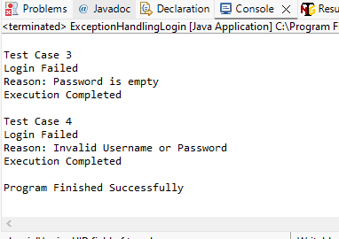

Task 5: File I/O Logging
package com.demo;

import java.io.BufferedWriter;
import java.io.FileWriter;
import java.io.IOException;

public class FileIOLogging {

public static void main(String[] args) {

String validUser = "admin";
String validPass = "admin123";

String[][] data = {
{"admin", "admin123"},
{"admin", "wrongpass"},
{"user", "admin123"}
};

try {

BufferedWriter writer =
new BufferedWriter(new FileWriter("result.txt"));

for (int i = 0; i < data.length; i++) {

String user = data[i][0];
String pass = data[i][1];

if (user.equals(validUser)
&& pass.equals(validPass)) {

writer.write("User : " + user +
" --> PASS");
} else {

writer.write("User : " + user +
" --> FAIL");
}

writer.newLine();
}

writer.close();

System.out.println("File Created Successfully");

} catch (IOException e) {

System.out.println("Error : " + e.getMessage());
}
}
}
Output:
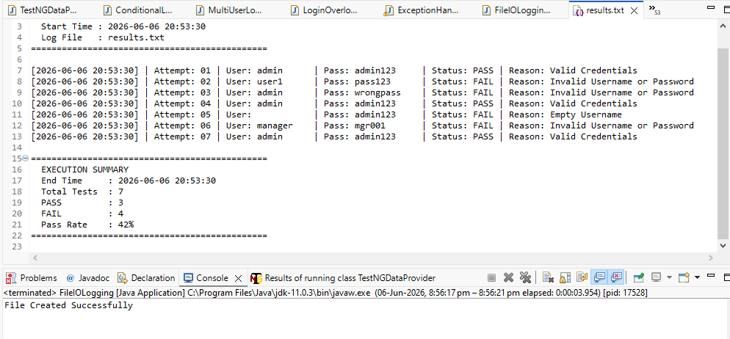

SECTION C: Mini Capstone Project
C.1 Test Planning Document
https://docs.google.com/document/d/1VJP9aSKUDNFdwVuySWKeNivF1JhasuLC/edit?usp=drive_link&ouid=102477484234567952398&rtpof=true&sd=true
C.2 Requirements Traceability Matrix (RTM)
https://docs.google.com/document/d/1b0B1Z-rb-fZDTdqXtGScBf4kbJxP2cYL/edit?usp=drive_link&ouid=102477484234567952398&rtpof=true&sd=true
C.3 End-to-End Test Scenario
https://docs.google.com/document/d/1zVgpiI16BPtEMemK0zztDRO7B69Y6Heb/edit?usp=drive_link&ouid=102477484234567952398&rtpof=true&sd=true
C.4 Test Summary Report
https://docs.google.com/document/d/1OoXdyqpmAzdNkO8uWZzn8EWVLHinPtHr/edit?usp=drive_link&ouid=102477484234567952398&rtpof=true&sd=true

